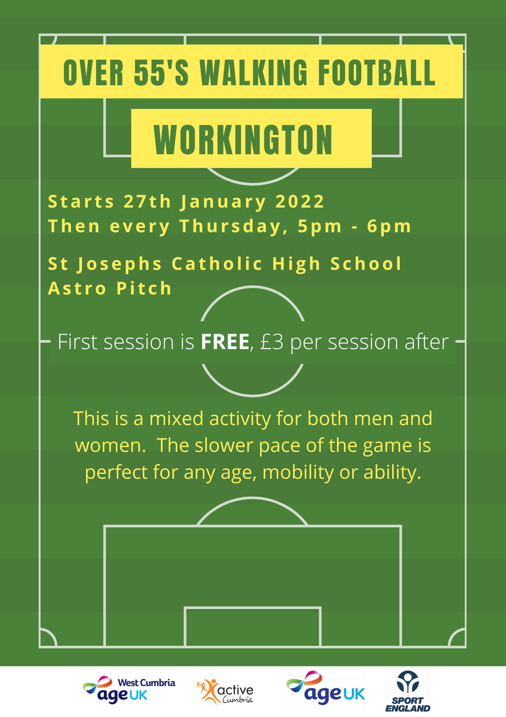

**For more information, please call**

**David on 07742547767 or visit the FA find football website**

<https://find.englandfootball.com/venue/194321802081>