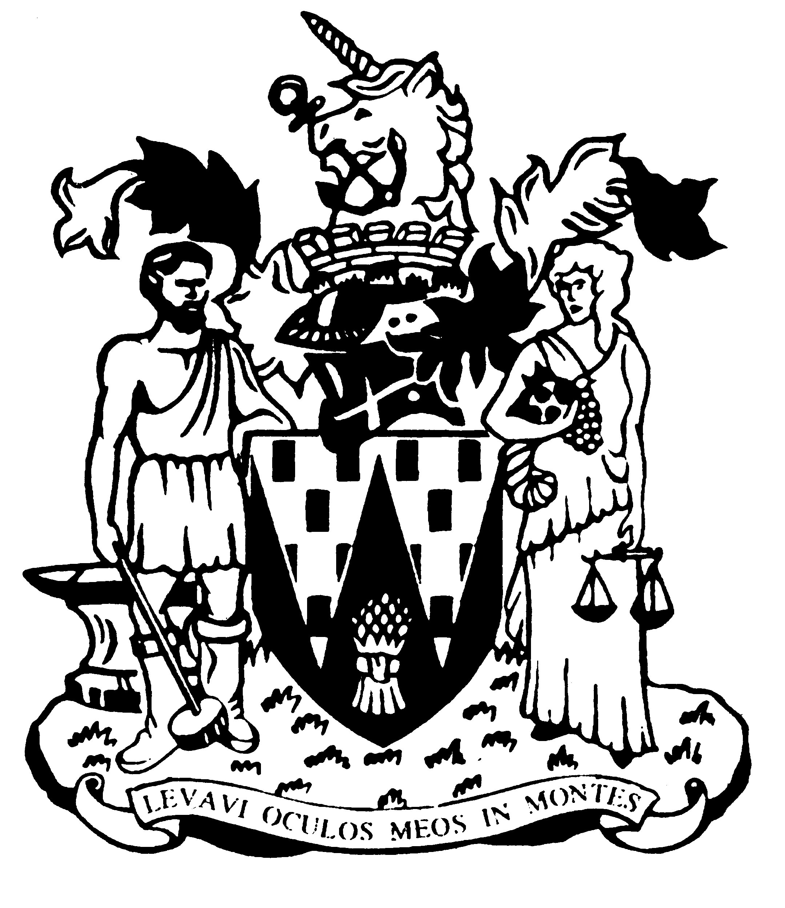

Workington Town Council

Annual Report 2018-19

Councillor Barbara Cannon
Mayor of Workington

Workington Town Council
Membership - March 2019
Name | Ward
Cllr Barbara Cannon (Town Mayor) | Moss Bay
Cllr Denise Rollo (Deputy Town Mayor | Salterbeck
Cllr Carole Armstrong | Salterbeck
Cllr Mary Bainbridge | St Michaels
Cllr Lillian Baldry | Salterbeck
Cllr Ann Bales | Moorclose
Cllr Peter Bales | Moorclose
Cllr David Cashman | St Michael’s
Cllr Beth Dixon | Northside
Cllr Mark Fryer | Stainburn
Cllr Konrad Hansen | St John’s
Cllr Hilary Harrington | Harrington
Cllr Michael Heaslip | St John’s
Cllr Peter McHarry | Ellerbeck
Cllr Frank Johnston | Stainburn
Cllr Joe Holliday | St John’s
Cllr Andrew Lawson | St Michael’s
Cllr Antony McGuckin | St Joseph’s
Cllr Billy Miskelly | St Michael’s
Cllr Jim Osborn | Harrington
Cllr Bill Reville | Salterbeck
Cllr Mike Rollo | Moss Bay
Cllr Kate Schofield | St Michael’s
Cllr Neil Schofield | St Michael’s
Cllr Matthew Suddart | Moorclose
Cllr Tricia Wardley | Iredale
Cllr Joan Wright | Moorclose

Annual Report 2018-19
The financial year 2018-19 saw the transfer of Vulcan Park to the Town Council from Allerdale Borough Council, along with the play area on Harrington Marina, and an additional piece of land at Bankfield, Newlands Lane, which brought the two halves of the football pitch back under a single ownership. The additions to the Town Council’s property holding complemented the adoption of a number of play areas, which means the total number of play areas in the care of the Town Council now extends to ten.
The year also saw the Town Council embark on an ambitious project funded by the National Lottery Heritage Fund to preserve the ruins of the Jane Pit coal mine in Moss Bay, as a lasting memorial to the mineworkers of the town. The iconic twin chimneys and engine house will form the centrepiece of an area of parkland, representing an anticipated investment from the National Lottery of over £300,000.
The Council continued its popular and innovative events programme, bringing Romeo and Juliet to Hall Park, and a massive Community Choir to the main stage to assist the Mayor in turning on the Christmas lights. Over 4,000 people attended the two-day Harrington Kite Festival, which is now established as a go-to event of the Summer, and the Party in the Park and the Family Fun Days continue to attract crowds in their hundreds to the town’s open spaces. Workington Go!, a day of sporting and activity tasters, was a sell out, and the England v Croatia game was brought to a big screen on the Cloffocks in partnership with the Borough Council.
Another successful co-operation with Allerdale is the Workington Nature Partnership, which delivered the long-awaited desilting of Harrington Reservoir. It was formally reopened by the Mayor and Sue Hayman MP, Shadow Secretary of State for the Environment at an event hosted by the local Friends group.
A Community Governance review in 2018 recommended new wards for the town.
Early 2019 saw the sad deaths of former Mayor of Workington John Bechelli, and serving Councillor Denis Robertson, and the Council’s condolences are conveyed to both families.
Chris Bagshaw, Town Clerk
An overview of the Town Council’s Accounts for the year ending 31 March 2019

The council collected £482,933 from council taxpayers in 2018-19. Additionally it received £7,460 as a Council Tax Support Grant, a payment from central government ‘passported’ through Allerdale Borough Council to compensate for changes to the way the council tax is calculated. Income from allotment tenants increased slightly as occupancy levels rose and there was an improved contribution from grants and sponsorship for events.
Staffing levels fluctuated as Councillors continue to review the council’s needs. At the year end the total complement will be FTE 5, set to increase to 7 by the end of April 2019 as the Council begins direct management of Vulcan Park.
The council also continued to fund the Workington Nature Partnership in conjunction with Allerdale Borough Council, which supports one member of staff.
The council’s brief year end receipts and payments (estimated, unaudited).
Income
Precept £482,933
Council Tax Support Grant £7,460
Rents and fees £38,797
Other income* £40,425
Total £569,615

Expenditure Total £620,450*
* This is an estimated, unaudited figure based on cash projections for the year end. The difference between income and expenditure was made from earmarked Reserve funds.
Full audit accounts will be available for inspection by the general public on 1 June.

A View on the Budget for 2019-20
The council has set a budget for 2019-19 based on a 7% increase for Band D council taxpayers. The council tax base for the town only increased by 2% in the previous year, meaning the council had to raise slightly more than anticipated. A Band D property in the town will pay £78.33 in parish precept, however the vast majority of properties are in Bands A and B, which will pay only £52.22 and £60.90 respectively, representing equivalent weekly increases of 6.6p and 7.7p per week, respectively.
It is anticipated that this will bring in a precepted income of £526,397. The Borough Council has now decided to completely phase out any contribution from their central government funding to the Town Council by reducing the council tax support grant to zero. This means the Town Council now shoulders the full burden of the changes made to the way that Council Tax benefits are calculated, by central Government in 2012.
The increased running costs for the council are largely attributable to the additional burden of Vulcan Park, but the Council has managed to reduce its overheads in other areas to lessen the impact of this. The long term investment in the condition of the Council’s allotment estate is beginning to wind down, and with the removal of Northside Allotments from the Council’s management on 1 April 2019, this investment can focus on renovating Annie Pit and Feenans, and ensuring that the estate does not fall back again to a challenging condition.
The investment in Cultural Events continues in 2019-20, with the Council’s Culture Committee allocating over £167,000 to the continued development of ‘cultural activities’. This includes over £45,000 for the continued safe installation and management of the town’s Christmas lights.
The Council’s commitment to the local environment is also reflected in its allocation of £112,500 to parks, play areas, nature reserves and allotments, as well as ensuring the town continues to put on an impressive display for Cumbria in Bloom

Chris Bagshaw, Town Clerk

WORKINGTON TOWN COUNCIL
Town Hall, Oxford Street, Workington, Cumbria CA14 2RS
Telephone: 01900 702986
Email: office@workingtontowncouncil.gov.uk
Website: www.workingtontowncouncil.gov.uk

