Workington Town Council
Community Centre, Princess Street, Workington, CA14 2QG
Telephone: 01900 702986
Email: office@workingtontowncouncil.gov.uk
Website: www.workingtontowncouncil.gov.uk

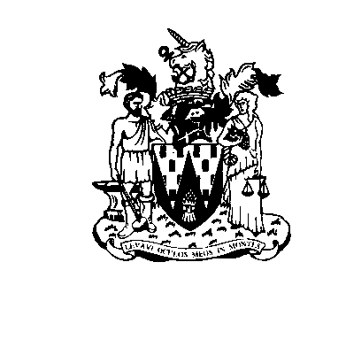

AVIAN FLU UPDATE
NEW HOUSING MEASURES
FROM 7 NOVEMBER 2022

It is a legal requirement for all bird keepers to keep their birds indoors & follow biosecurity measures.

The restrictions apply to all poultry & captive birds.

You must keep them separate from wild birds. You can find details at:

Avian influenza (bird flu) Latest situation
(www.gov.uk/guidance/avian-influenza-bird-flu#latest-situation)

If you keep poultry or captive birds, you must comply with the restrictions. If you do not, you could be fined and may lose your tenancy.

