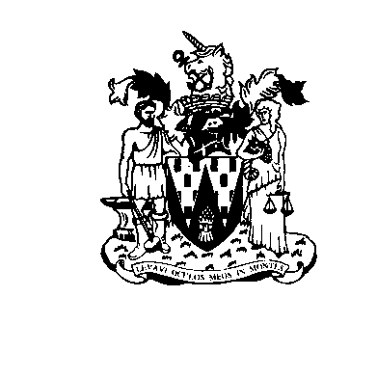
Workington Town Council
Workington Town Council Community Centre, Princess Street,
Workington, Cumbria, CA14 2QG
Telephone: 01900 702986
Email: office@workingtontowncouncil.gov.uk
Website: www.workingtontowncouncil.gov.uk

Minutes of the Culture Committee of Workington Town Council, 7pm Monday 7th November 2022 held at Workington Town Council Community Centre, Princess Street, Workington.

Cllr C Armstrong | Present
Cllr R Briggs | Apologies
Cllr B Cannon (Chair) | Present
Cllr B Dixon | Absent
Cllr S Fryer | Present
Cllr D Garton | Present
Cllr A McGuckin | Absent
Cllr P Poole | Present
Cllr P Scott | Apologies
Cllr L Williams | Present
Cllr E Wood (Vice Chair) | Present

In attendance: Town Clerk for Workington Town Council and Cllr B Miskelly

C22.54. Apologies
Apologies were received and noted from Cllrs R Briggs, and P Scott.

C22.55. Declarations of Interest
None

C22.56. Exclusion of Press and Public (Public Bodies Admission to Meetings Act 1960)
No agenda items were identified as requiring the exclusion of press or public.

C22.57. Minutes of the Previous Meeting
The minutes of the meeting on 5th October 2022 were agreed as an accurate record.

Resolved: To agree the minutes of the 5.10.2022.

C22.58. Budget Considerations
The committee resolved to vire £2,500.00 from the festival budget line to the theatres budget line to restore the budget which was showing a shortfall due to an error.

Resolved: To vire £2,500.00 from the festival budget line to the theatres budget to restore the budget which was showing a shortfall due to an error.

C22.59 Christmas Light Re-tender
The committee noted that this is the final year of our Christmas Light contract with Millennium Quest.

The committee considered changes to the current requirements – in future payments must be made in instalments and not 100% upfront.

This year…
- The tree usually at the train station will be gifted to the Leisure Centre. This is because of vandalism reported by the Rail Company.
- All lights on trees to be of consistent size and number.
- Enquire if Northside require a tree.

Resolution: To note that future contracts for Christmas trees must have payments in instalments.
Resolution: To move the tree from the train station to the Leisure Centre.
Resolution: To ensure all trees are decorated with lights that are equal in size and number.
Resolution: To enquire if Northside require a tree.

C22.60. Events equipment purchased
The Committee noted that the events team have purchased 9 x new A1 boards @ £780 from the festivals budget line.

Resolution: To note a spend of £780.00 for events A Boards..

C22.61 Christmas update
The Committee noted the following report:
- Main stage will now be in the Marks and Spencers car park.
- Lantern Parade - a lantern making workshop will be held at Moorclose Community centre for the public on Sat 19th November from 1pm-4pm. In additional to this, SWYP will run workshops with the children in school - the workshops are offered to all schools within Workington, but usually the ones that take up the offer are Victoria, Ashfield, Westfield & St. Gregory's.
- Funding of £500 secured from Dobies Charitable Trust for entertainment at the Christmas Festival.
- Cllr L Williams will be helping to marshal the lantern parade.

Resolution: To note the report.

C22.629. Culture Committee meeting – November

The Committee decided on an additional meeting on 5th December 2022 to consider the following:
- Events for 2023/24 The Chair asked committee members to come prepared to consider the events for next year and what they would like to see happen. It will also be an opportunity to review events we have been holding and to consider if we want to continue having the same offer or if there is an opportunity for change. It is also an opportunity for committee members to consider how they promote more acivities within communities.
- To give consideration to what events members would like to see for the Kings Coronation on 6th May 2023
- The Chair noted that our French twin town has been holding a marathon this summer. Committee to consider if Workington could also hold a marathon or half marathon as part of our sports offer.

Resolved: To hold an additional Culture Committee meeting on 5.12.2022.

Meeting closed at 19.37

